Gumball Machine

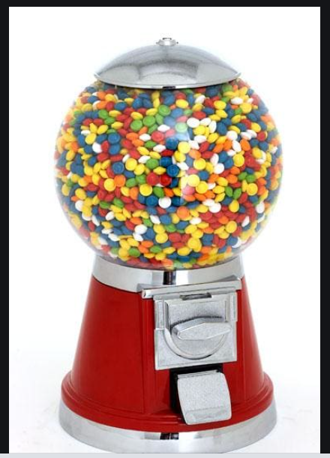

What does a Gumball Machine do?

What information does a gumball machine need to function?

**Nouns**

Gumballs

Coin slot

Money

Gumball container

Coin mechanism

Gumball dispenser

Coin box

Coin count

Gumball count

**Verbs**

Accept money

Dispense gumball

Turn knob/activate mechanism

**What does a Gumball machine need to do to function?**

**Use Case 1 (Happy Path)**

Customer insert coin

Turns knob

Receives gumball

**Use Case 2 – No candy**

Customer inserts coin

Turns knob

No candy returned

Coin stays in slot

**Use Case 3 – incorrect coin**

Customer inserts incorrect coin

Turns knob

No candy is returned

Coin remains in the slot

**Use Case 4 – Owner cashes out and refills**

Owner opens coin box

Report #coins and amount

Reset coins to zero

Reset gumball count to max